What is Xcode?
Xcode is an Integrated Development Environment (IDE) for developing apps in the Apple ecosystem. We'll be focusing on iOS apps, but you can also make apps for macOS, watchOS, and tvOS apps. IDEs (like Xcode) contain and integrate many powerful tools that make software development easier for programmers.

Create a new Xcode project:
- Open Xcode on your computer. You should see the following launch window after you open Xcode
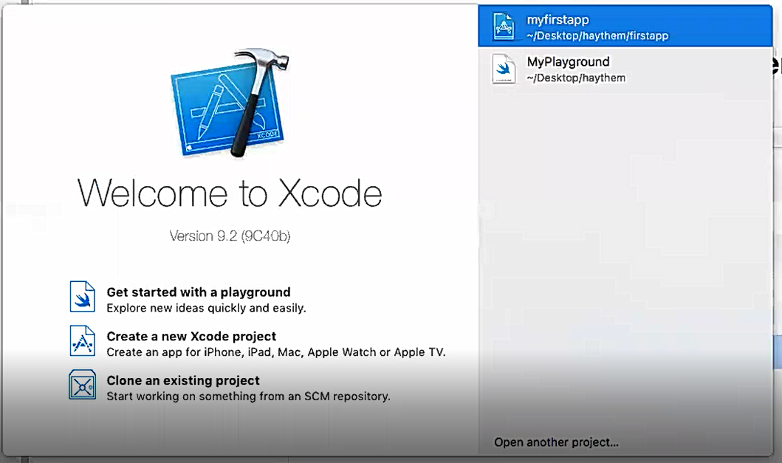
- Next, from the launch window's quick options click Create a new Xcode project
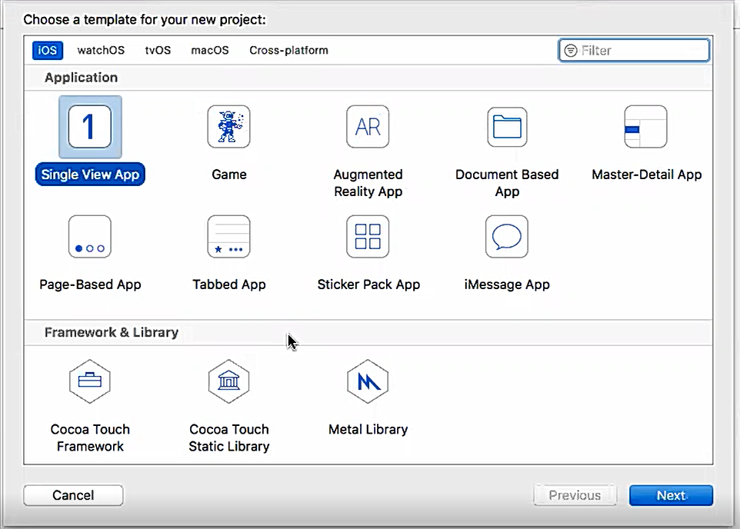

- You should see the following prompt to select a template for your new project. Under iOS, select Single View App
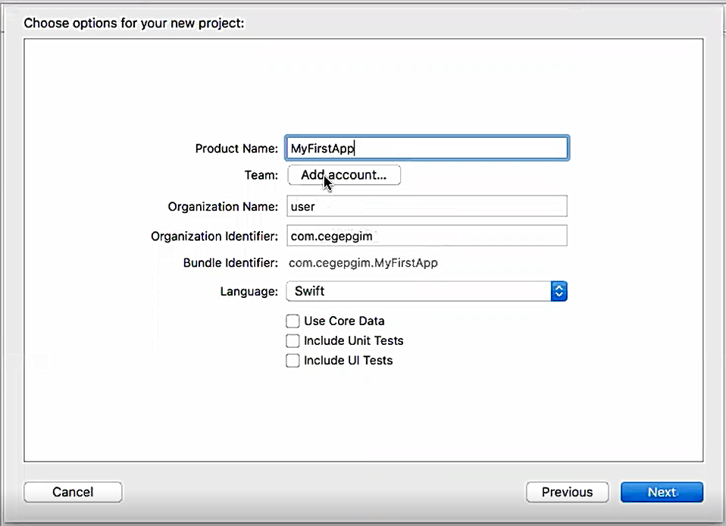
- With your selected template, click Next. You should see a new prompt for your project details. In this new prompt, we'll set some basic info and details that Xcode needs to create a new project. After filling out your project details above, click Next.

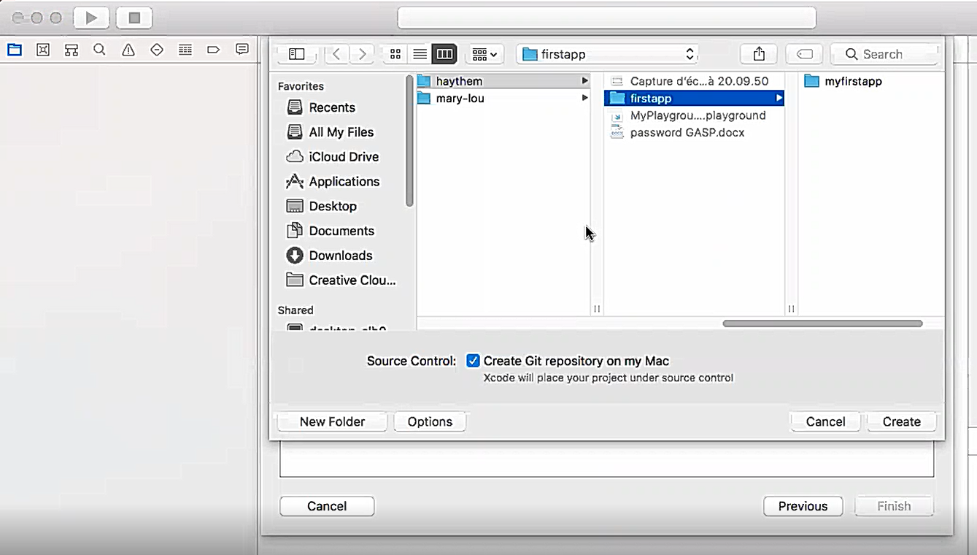
- Xcode will now prompt you to select where you'd like to store your project. Using the file navigator, choose to a place on your computer to store your project. If you don't have a place in mind, you can use your Documents folder.
- Make sure you keep the Source Control checkbox selected for Create Git repository on my Mac. After you've selected a project location and verified that the Source Control checkbox is selected, click the Create button.

